Dear Town Clerk, Communications Officer and Town Councillors
BEXHILL-ON-SEA WILD DOMESDAY PROJECT
THIRD THREE-MONTHLY REPORT
In accordance with my contract, here is the third report on the Bexhill Wild Domesday Project covering the period from 1st January to 31st March 2024.
Introduction
This project began on 1st June 2023 and has now been extended for a further year and so is due to end on 31st May 2025 unless continuance is agreed. The overall project is designed for three years of landscape and wildlife evaluation, conservation and enhancement in the nine wards of the town. Extensive progress has been made across a range of projects.
Community Interest Company
As previously mentioned in my second quarterly report, I have registered an independent legal community interest company (CIC) with Companies House to obtain grant funds for projects. The CIC has four directors, and a business bank account. This company is called Bexhill Wild Domesday CIC and it covers the coastal area from the edge of Eastbourne and Pevensey Marshes to Rye Harbour. The CIC has already attracted grant funding and is being supported with grant advice by Emma Dean of East Sussex County Council. A written invitation to apply for Project-by-Project match funding has been received from Rother District Council.
Data Analysis for Wildlife Conservation
To understand how Bexhill’s wildlife assets are being conserved or lost due to climate change I have obtained a grant of £4,000.00 to cover the cost of the digitisation of 130 years of wildlife records held by the archivist of the Hastings & East Sussex Natural History Society. This will provide a year-by-year trend analysis derived from PDF search capability using any keyword. The digital scanning began on Tuesday 26th March and is expected to take several weeks, but when completed it will give us a clear idea of which species used to be part of Bexhill’s biodiversity and which species are in decline. There will undoubtedly be good news too as recent sightings of exceptionally rare bees, previously thought to be extinct in Britain, have been reported at Galley Hill and there has been a rapid growth in numbers of previously rare Willow Emerald and Small Red-eyed Damselflies in Combe Valley. More on this below.
Water in the landscape
Although we might think we have enough rainwater at present, with Combe Valley heavily flooded and extensive flooding in the recent past in Egerton Park, the summer projection of temperatures approaching 42 centigrade will mean that many Bexhill woodlands dry out. I have therefore obtained a grant of several thousands of pounds which will be partly used for purchasing the water equipment mentioned in the previous quarterly reports and presentations to the Town Council’s Climate Committee. I am now going to enter a period of discussion with Bexhill Environmental Group as to where this equipment can be stored and how it will be used to alleviate the loss of wildlife habitats when the inevitable drought periods occur.
Wildlife Tracking
Birds
I have obtained grant funding to purchase PUC Bird tracker equipment both mobile and fixed position. This equipment uses a high gain microphone and artificial intelligence to electronically identify all UK resident birds and periodic migrants. It places the data online so that everyone in Bexhill will be able to see which birds are here all the time and which are passing through. This will enable a year-on-year bird diary showing the months in which various birds are present. So, for example, the European Robin and Eurasian Wren will be here all year round, but the Northern Wheatear will be here as a migrant from May to October. The equipment software is automatically updated.
This tracking equipment has been ordered and will arrive on 9th April 2024 and so all public areas of Bexhill, all accessible woodlands in each of the nine wards, the coast and Combe Valley will now be tracked for bird identification. It is hope that the people of Bexhill will welcome the ability to see everything avian that is happening in their community. Full details of the tracker website will be made available, probably in late May when I have set it all up. There is a Red List of UK birds at risk and the Bexhill results will be matched against that list to see if further conservation projects are feasible.
Bats
As David Attenborough said on TV this week, bats are the largest group of mammals in the world, yet many people do not know very much about them. However, in Sussex, remarkably we have all 18 UK species. Furthermore, we now have a 19th addition beginning to show. This is Nathusius’ Pipistrelle which flies in from Poland and Lithuania. I have obtained grant funding for very sophisticated bat tracking equipment (which also tracks birds, grasshoppers and crickets and small mammals such as voles, dormice and harvest mice.) This bat tracker will also produce online results so that the people of Bexhill can see what is happening at night.
Sidley Stream Project
This is progressing well, with a grant of £1,000.00 as a starter fund from Jo Shiner, Sussex Chief Constable already obtained. This is twice the normal grant from the PPA Fund so is a significant honour.
The background to this project is that in early medieval times, well before the Norman Conquest, the coast of Bexhill had a forest and a huge shingle island stretching for around 2.5 miles across the settlement frontage. North of this was the Pell, a torrent (hence the term ‘Pell-Mell’) that came down from where Sidley is now, forming a lake and then and flowing into the sea opposite the shingle island.
Now in 2024, the area of the ancient Pell Lake is called Egerton Park. The Sidley stream is the headwater of the Egerton Stream. Town planners have permitted the ravine landscape of Sidley to be completely covered in concrete roads and pavements, and more recently concreted front gardens used and car parks. Since the surface material chosen is impermeable, the rainwater rushes down the slopes of a very large area of housing on the hillsides above the ravine. Because the Egerton Stream and the Pell have lost their natural flood plain due to overbuilding and the construction of the huge wall of earth generated at Sidley Recreation Ground, and because the tide gate is blocked by sea water at high tide, then almost the whole of Egerton Park floods to a depth of around three feet. As climate change brings higher sea levels due to 40% molecular bulking, so the flooding will occur more frequently.
To alleviate flooding and certainly to alleviate its rapidity, the Bexhill Wild Domesday Project has arranged for an expert from the South East Rivers Trust to visit the site at 10 am on 2nd April 2024. The expert has assessed that small changes to the flow of the water using leaky dams and small pools will reduce flooding. The expert will now return in May to design the scheme and provide costings. The Trust has also offered to provide two expert supervisors for the Sidley Volunteers who will do the work and these volunteers will be covered by the Trust’s public liability insurance because the qualified supervisors are present. Once the scheme has been designed, it will be submitted to the Environment Agency for a licence and the expert was confident that one would be issued. The next stage would be to hold a public meeting in the Pelham Hotel, Sidley to ask for volunteers. The whole scheme will be submitted to Rother as the Planning Authority. If they grant planning, then work will start on the stream after the bird nesting season is over. The whole of Sidley woods will be mapped using the bird PUC mentioned above. Planting of some nettlebeds and placement of woodpiles will enable the area to be suitable for the recovery of the Small Tortoiseshell butterfly which is in serious decline in UK. Further possibilities will be an increase in blackthorn and hawthorn bushes for bird winter berries and the placing of a small number of black popular tree saplings which require very wet and muddy habitats. These trees are increasingly rare as they require both male and female trees to be present and the UK estimate is that there are only between 100 and 600 female trees left in UK so urgent action is needed. The Sidley Stream is ideal for this type of tree. Extra scrapes will be made for dragonflies and damselflies.
This is a lovely area for peace and quiet. In the longer term it will be possible to improve the path so that it is suitable for people using wheelchairs and strong fireproof benches can also be provided.
Saving Galley Hill
A draft letter has been sent to the Town Clerk setting out the Council’s concerns over the level of protection of Galley Hill. The Council is considering if it will send the letter to the Secretary of State for the Environment. Please see Appendix 1 to this report which details the wildlife and landscape at risk because Natural England have not extended the Combe Valley SSSI to cover Galley Hill.
Volunteers and their training
The plan for volunteer training is set out at Appendix 2 to this report. However, it is requested that Bexhill Town Council urgently fix a date in July for the public meeting at St Barnabas Church, so that advertising of the event can be sent to local newspapers. Please also provide a microphone system as was done in 2022.

Open Day at Combe Valley
Bexhill Wild Domesday Project will have a marquee at the Friends of Combe Valley Open Day on – where information on volunteering opportunities will be given out in printed circulars.

The event takes place from 1pm to 4pm on that day.
SSSI Appraisals
Bexhill has three Sites of Special Scientific Interest and around twenty remaining areas of ancient woodland dating back to more than 400 years ago. The SSSIs are:
- The Bexhill half of Pevensey Marshes SSSI
- Highwoods SSSI
- The Bexhill two-thirds of Combe Valley SSSI
The major ancient woodlands are:
- Gillham Wood – An RDC woodland managed by Sussex Wildlife Trust
- Collington Wood – An RDC woodland managed by them
- Highwoods – An RDC woodland managed by a registered charity which is also a SSSI
- Cooden Woods – An RDC woodland
- Other areas of ancient woodland of varying sizes are:
- Wetwood/Kite’s Nest, Gotham, Smith’s Kiln, Levett’s, Worsham, Henniker, Park and Ring. There are also many small areas with a few trees that are vestiges of ancient woodland that also need conservation as they are listed by government.
All the SSSIs have problems so I have carried out an analysis which shows a shockingly poor level of monitoring by Natural England. It is very important for Town Councillors to understand the situation inside the Bexhill ward boundary. The situation in each area is shown below.
Pevensey Marshes (SSSI/RAMSAR/NNR/SAC)
This area covers 3586 hectares of which around 1793 hectares is inside Bexhill. As well as being an SSSI, this is an international wildlife asset know as a RAMSAR. This ‘Ramsar’ is the name of the town in Iran where the first wetland protection conference took place in 1971. Pevensey Marshes is also a National Nature Reserve (NNR), and it is an SAC (Special European Area of Conservation) under the JNCC (Joint Nature Conservation Committee). The JNCC was established under the Environmental Protection Act 1990 and the Natural Environment and Rural Communities Act 2006. On 25th March 2019 special instructions were issued by JNCC for the conservation of Pevensey Marshes under site code UK0030367 for specific action under law. There is a twelve-page document available telling those responsible for the management of Pevensey Marshes how to care for the Ramshorn Snail and the Great Raft Spider ditches. This can be sent to the Town Clerk and/or councillors upon request to the undersigned. It is understood that the ditches are not being managed correctly.
Highwoods SSSI and Ancient Woodland
This site of 34 hectares is in an unfavourable state but is considered by Natural England to be recovering. Natural England has named it High Woods SSSI despite its local Bexhill name. It is described as:
‘An interesting wood with a range of habitats. The ghyll valley and alder carr it contains provide a distinct wetland flora. Notably part of the wood contains pendunculate oak coppice which is now in management. The wood also features hornbeam and sweet chestnut. Rides and glades, particularly those underneath pylons, feature a distinctive heathland habitat. The woodland is currently being effectively managed through coppicing and by maintaining some open glades. The ground flora is diverse in some areas and regeneration and understorey levels outside coppices areas are good. Rhododendron has been all but eliminated from this woodland over the last five years.’
However, this is misleading, in that this report was written on 24th August 2010 and, according to their own data the wood has not been checked by Natural England for fourteen years.
Combe Valley SSSI
This area covers 153 hectares of which around 102 hectares are inside Bexhill’s wards. Natural England has specified that Combe Valley is inside the High Weald whereas the High Weald Authority shows it plainly to be fully outside. I am resolving this with the High Weald Authority to find out why such a mistake has been made. If it could be brought inside the High Weald boundary, it would make a great difference to conservation funding availability.
Natural England states that Combe Valley SSSI has several problems, but it has done nothing to redress them as the Natural England officer responsible has not reported since 16th March 2021. On that date the Valley was ‘high risk’ due to ‘scrub encroachment’. Combe Valley’s woodlands were also assessed as ‘high risk’ (see risk chart below). The question is – since there are multiple owners – who is taking responsibility?
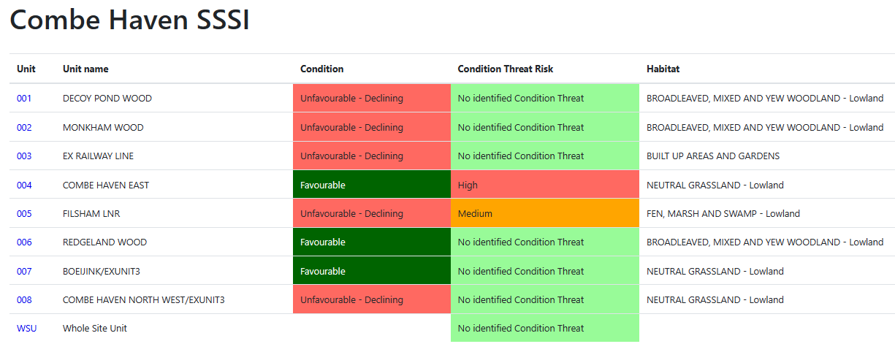

Relations with Other Organisations
Bexhill Wild Domesday has excellent relations with many organisations including the Environment Agency, Friends of Combe Valley, South East Rivers Authority and Strandliners.
Pollution of the Bexhill Environment
Since Bexhill is within Rother District Council (RDC) I asked for a formal response from Rother concerning how they deal with pollution. Several parts of RDC were consulted by Dr Lucy Bolton the RDC Ecologist. This is the RDC statement:
‘The Council does not conduct any ecological assessments. In the event of a pollution incident, we would work with partner agencies, such as the Environment Agency, Marine Management Organisation, ESCC and HM Coastguard to manage the incident. This may involve assessing the pollutants, but these wouldn’t be conducted by RDC.
Regarding water quality, The Bathing Water Directive is administered by DEFRA and implemented by the Environment Agency on their behalf. Water companies are responsible for obtaining environmental permits for storm and emergency overflows, and the Environment Agency are responsible for monitoring, assessing and classifying bathing water and providing bathing water profiles.
Monitoring the environmental impact of pollution would lie with the Environment Agency. They would be the organisation you would need to contact about the readings.
The Council is working with several organisations to reduce pollution in the rivers and sea. We are working with the South East Rivers Trust in two catchment partnerships – The Rother and Romney and the Cuckmere & Pevensey Levels on a landscape-scale approach. We are also working with Strandliners and others to raise awareness of pollution and the devastating impacts it is having. The Council also supports a number of litter-picking initiatives by providing equipment and arranging for the disposal of any waste collected Voluntary litter picking – Rother District Council.’
Bexhill Town Council is asked to consider if it will implement its own sampling regime or if it is content to accept the stance set out by RDC above.
LNRS Briefing
I attended the LNRS Briefing for Sussex-based community groups and organisations active in nature’s recovery on Monday 25th March from 6-7pm. Please can the Town Clerk inform councillors that the LNRS is a legal requirement. I would like to present a set of slides from the LNRS to the next meeting of the Council so that everyone understands how the LNRS works.
Local Nature Recovery Strategies (LNRS) are a new way to help nature from the Environment Act 2021 that are rolling out across England. They aim to agree the priorities for nature’s recovery at the county level, determined by the people who live there and the organisations who work there. There will be two LNRS for Sussex. One will cover East Sussex and Brighton & Hove, and the other will cover West Sussex.

The online briefing I attended was for Sussex-based community groups and organisations already working to benefit our natural environment, which includes those who:
- restore or maintain green and wilder spaces,
- demand action on climate change and biodiversity loss,
- provide education or access to nature,
- encourage more sustainable ways of living,
- coordinate or connect smaller groups.
The LNR understand that Bexhill will have existing priorities and projects, as well as ecological knowledge of their local area and expertise in implementing actions for nature. Because of this, they can play an essential role in helping to shape and deliver their Local Nature Recovery Strategy. This online briefing covered:
- What LNRS are and how they'll work
- Why they're needed
- What is in their scope (but also what's not)
- How to get involved.
- Q&A - put your questions to the panel
The briefing on the LNRS was given by:
- Kate Cole - County Ecologist, East Sussex County Council
- Don Baker - Team Manager, Environment & Heritage, Planning Services, West Sussex County Council
- Julie Middleton - Policy Lead, Sussex Nature Partnership
Conclusion
The Bexhill Wild Domesday Project is well-positioned to fulfil all its aims and give Bexhill an exciting future with a high level of biodiversity conservation. We can now move to the next phase, holding a public meeting, identifying and training volunteers and continuing to obtain grants to enable the various project to go ahead. Now that we have our own CIC, we will be able to make rapid progress. I would be happy to meet with councillors and to answer any questions. Ideally a comprehensive presentation lasting one hour would give everyone involved a clear idea of what is to happen to Bexhill from the LNRS perspective.
David EP Dennis BA (Hons) FCIPD AFRHS LCGI RAF
Wild Domesday Project Manager
Bexhill Wild CIC
07969 088186
davidbexhill@live.co.uk
Date: 4th April 2024

Appendix 1
The Wildlife and Landscape of Galley Hill, Bexhill-on-Sea, East Sussex
Introduction
The long line of sandstone cliffs at Galley Hill date to 140-180 million years old. The wavecut platform seen at low tide contains the footprints of the Iguanodon dinosaur. There is an ancient forest remnant gradually turning to stone. The shingle has turned into a fine vegetative beach pavement habitat with Sea-kale (Crambe maritima) beds and Yellow Horned-poppy (Glaucium flavum). The cliffs have many thousands of small holes cut by mining bees. Some of these bees are very rare. The location is also an insect hunting ground for the migratory ground nesting Wheatear bird from Kenya and Senegal. Other birds include types of gulls, a large flock of some 280 Turnstones (migratory to Greenland), many Oystercatchers and around 80 Cormorants. The beach is now frequently visited by Seals. As well as the Silver Y moth, there is evidence of the Six-belted Clearwing Moth. The Green Tiger Beetle lives and mates here as does the Pill Millipede.
Known Rare Bees mining at Galley Hill requiring urgent conservation status
Early Colletes (Colletes cunicularius)
Grey-backed Mining Bee (Andrena vaga). This was previously thought to be extinct in Britain.
Other bees mining the cliffs
Gwynne’s Mining Bee (Andrena bicolor)
Yellow-legged Mining Bee (Andrena flavipes)
Cliff Mining Bee (Andrena thoracica) (local cliffs are only last refuge of this bee in Sussex)
Hairy-footed Flower Bee (Anthophora plumipes)
Silvery Leafcutter Bee (Megachile leachella)
The Mourning Cleptoparasitic bee (Melecta albifrons)
Spined Mason Bee (Osmia spinulosa)
Buffish Mining Bee (Andrena nigroaenea)
Trimmer’s Mining Bee (Andrena trimmerana)
Hairy Yellow-face Bee (Hylaeus hyalinatus)

NB: The secret of Galley Hill is that although its cliffs are generally barren in their upper and mid-sections apart from the foreign incursive but usefully rock-binding Hottentot Fig (Carboprotus edulis), the lower levels contain many plants sought out by bees and the whole of the top of Galley Hill is a clover-rich lawn of good moist grass for many months with many flowers.
The proximity of the flowered grass to the soft sandstone bee-mining potential is key.

Migratory birds
Northern Wheatear (Oenanthe Oenanthe) (very scarce in Sussex) but recorded each year at Galley Hill.
Ruddy Turnstone (Arenaria interpres – variety (Linnaeus, 1758)
Other birds
Great Cormorant (Phalacrocorax carbo)
Eurasian Oystercatcher (Haematopus ostralegus)
Goldfinch (Carduelis carduelis)
Herring Gull (Larus aregentatus)
Black-headed gull (Chroicocephalus ridibundus)
Great Black-backed gull (Larus marinus)
Significant insects
Green Tiger Beetle (Cincindela campestris) breeding
Pill millipede (Clomeris marginata)
Significant moths
Six-belted Clearwing (Bembecia ichneumoniformis) – nationally scarce
Silver Y (Autographa gamma) not rare but is migratory
Mammal
Common Harbour Seal (Phoca vitulina) – less common than the Grey Seal
Considerations
When the SSSI Extension is made then the South Coast Cycle Way and the South Coast Footpath could be routed and signposted over Galley Hill on the existing hard surfaced path from Glyne Gap to Bexhill-on-Sea seafront, rather than on the beach level footpath so close to sensitive wildlife areas.
Appendix References
Barnard, P. The Royal Entomological Society Book of British Insects (2011) Chichester, Wiley-Blackwell.
Hume, R. RSPB Guide to the Birds of Britain & Europe (2014) London, Dorling-Kindersley.
Power, J. The Bees of Sussex (2024) Newbury, Pisces Publications.
Sterry, P. and Cleave, A. Collins Complete Guide to British Coastal Wildlife (2012) London, Harper Collins.
Waring, P. and Townsend, M. Field Guide to the Moths of Great Britain & Ireland (2017) London, Bloomsbury.
Appendix 2
BEXHILL WILD DOMESDAY PROJECT
VOLUNTEER TRAINING
Overview
The Bexhill Wild Domesday Project began on 1st June 2023 and its first research phase is due to end on 31st May 2024. The Year Two phase began on 1st June 2024 and in this next phase, eighteen volunteers will be required, two per Bexhill ward. A public meeting will be held to explain the need for volunteers to come forward. Training will be offered to those volunteers following formal application and selection.
Training
The basic and advanced training courses are being developed during the Spring of 2024.
These training courses will be given to 18 volunteers, two per ward.
The aim of the training course is to ensure that the volunteers are insured and can operate safely and competently to observe, review, conserve and enhance wildlife and landscapes in their own ward. They will be managed by the Bexhill Wild Domesday Project manager, and they will be supported by grant funding for projects to be implemented. Specialist organisations will be asked to help.
The funding will be obtained by the Bexhill Wild Domesday CIC, a community interest company set up in December 2023 to support conservation projects from the Pannel Valley to Pevensey Marshes including Bexhill and Hastings – registration number 15352284.
Social Development Principles
Volunteers will be asked to follow the guidance from Sussex Wildlife Trust in aiming to make life better in each ward of Bexhill over time using these four principles:
1. the promotion of sustainable development,
2. promotion of cultural and community values,
3. conservation of the natural environment, including ecological vitality
4. and establishment of good governance.
Basic Training Overview
The training programme will include aspects of wildlife and landscape conservation and enhancement, and the aim is to ensure volunteers feel happy and confident in their roles. They do not have to be scientific experts in any aspect of conservation work, but they do need to know their wards and local landscapes thoroughly and demonstrate a long-term wish to participate in patrolling their area, making reports, and working with other groups to achieve targets. The age limit for these volunteers will be 18 to 85.
Volunteers will operate from their own homes, gathering facts, photographing wildlife and plant life recording their findings on a national online database and monitoring their environment across a range of aspects set out below.
There is no need to patrol at specific times each day or week, but monthly reports through the season will be invaluable in developing a deep understanding of what is happening in the ward.
Basic Training Phase
Initial training will cover:
A slide presentation covering a map-based overview of each ward and its current natural assets including landscape types, water courses, tree preservation orders, the implications of climate change and sea level rises, aspects of ground water and flooding. Wildlife and plant life information will cover the basic categories found in Bexhill-on-Sea today:
(1) Mammals (2) Birds (3) Reptiles & Amphibians (4) Fish (5) Insects that are butterflies or moths (6) Other insects, spiders (7) Molluscs, terrestrial land freshwater crustaceans, seashore crustaceans, other terrestrial and freshwater invertebrates, other seashore invertebrates (8) Trees and shrubs (9) Wildflowers (10) Grasses, rushes, sedges, lower plants, fungi.
During basic training, volunteers will learn about risk assessment, health & safety awareness, first aid and a clear understanding of the Project Occupational Health and Safety Policy and Lone Worker Policy, Equal Opportunities Policy and the limitations of public liability, personal data protection (non-fee) and personal protection insurance.
Basic training will also cover clothing to be worn, how to take effective photographs using a mobile phone, how to use GPS to mark locations for further review, how to identify threats to landscapes and wildlife, how to record findings and how to report information to the Project manager so that a comprehensive picture of each ward can then be used to make decisions on future work.
Volunteers will ideally work in pairs and aim to become all-rounders in their wards, not just specialist in any one aspect of nature. The aim is to obtain an overall picture of the environment of their ward. If a volunteer decides to work alone because a colleague is on holiday or off sick, they will need to have regard to our Lone Worker policy.
Volunteers will learn how to use iRecord for the National Biological Network
Advanced Training
As projects are appropriately planned for each ward, the next phase will be advanced training. This will be additional training on the types of landscape already identified by the Domesday Project: coast, fen, marsh, meadow, farmland (dairy, beef, sheep and arable), woodland, urban, parks & gardens, private gardens and recreational areas and pathways. The training will also cover specific tasks like tree and hedge planting, plant and tree identification and insect identification using computer application and bat and bird identification using electronic analysers.
In this advanced training volunteers will learn a broad overview of the following landscape and wildlife conservation aspects connected to climate change:
Coastal Habitats and their management, Saltmarsh, Saline lagoons, Shingle, beach cleaning.
Grazing marshland at Pevensey and Combe Valley, predator fencing for ground nesting bird protection, underground nesting for Wheatears at Galley Hill, rabbit enclosures where rare plants are found in a landscape, the provision and use of nest boxes.
Understanding wetlands, water level management, marine conservation areas of our coast, kelp recovery, sea grass planting, tidal outflow and influx, sea levels and coastal erosion and the work of the Environment Agency.
Learning about meadows and unimproved grassland, grass cutting and the interrelation of these areas with bees, butterflies, spiders, beetles, waxcap fungi, and small mammals.
Woodland life and tree identification and conservation.
Dogs, Sheep and Cattle Safety, the law on the use of drones, the laws protecting wildlife including beavers.
Private front garden pollination corridors.
Major nature pathways of the local area.
Food chain and raptors.
Clothing
Some landscapes are urban with hard standing but there are areas of woodland and marsh that will require wellingtons or strong boots and clothing worn need to be appropriate to the season. Gloves will be needed. Volunteers will be asked to use common sense about weather conditions and there will be no requirement whatsoever to hazard personal safety.
Sussex Wildlife Trust advice is for volunteers to wear long trousers (even in the summer) for protection against plants and bites, and long-sleeved tops (again even in summer) if working in natural as opposed to urban hard standing environments. Volunteers will need a waterproof coat and a hat to protect from the sun. Volunteers should take water with then when they are patrolling. Volunteers will need to think about toilet requirements prior to setting out on long routes.

Wards Map

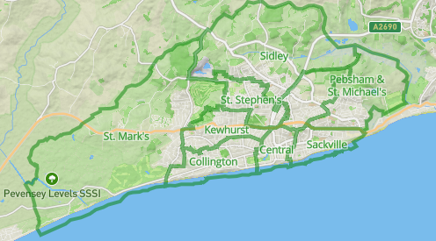

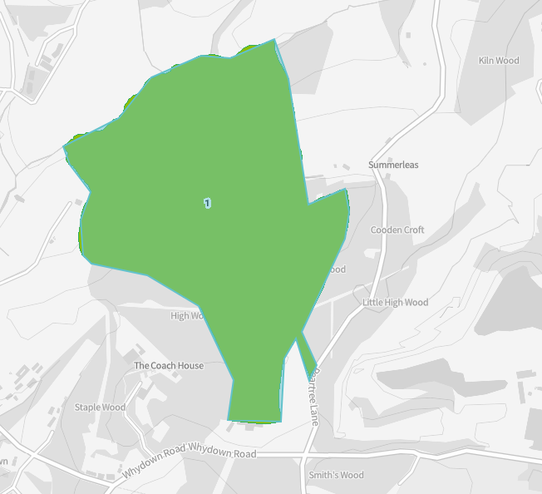
The government map of Bexhill’s only area of ancient woodland that is an SSSI.

